**ORDER FORM**

**Our Lady’s Girls’ Primary School Leavers Hoodie 2024**



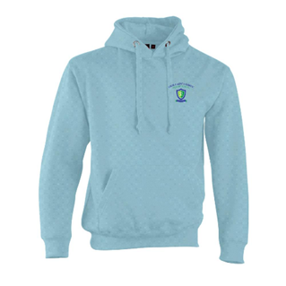

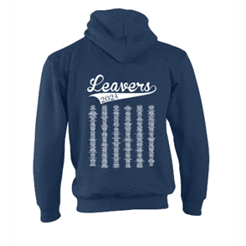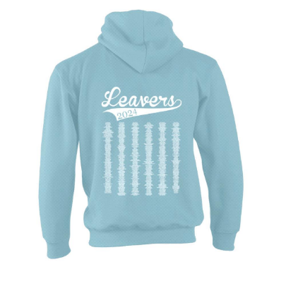

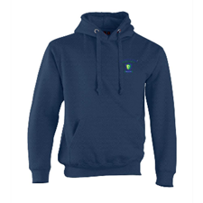

NAVY

POWDER BLUE

**We are delighted to be able to offer ALL pupils the opportunity to purchase a Leavers Hoodie this year.**

**The cost will be subsidised by the PTA and will only cost you £5.**

**All orders, with money, must be returned by THURSDAY 7TH MARCH and must be on this form.**

**It is your responsibility to order the correct size, refunds and returns will not be available.**

**Late orders cannot be processed as we are getting discount for ordering in bulk.**

**Daughter’s name …………………………………………………………………..**

**Class ……………………..**

**Colour …………………………………….**

**Size** …………………… (see links sent via text and on website for advice on sizing) Payment included …………………………