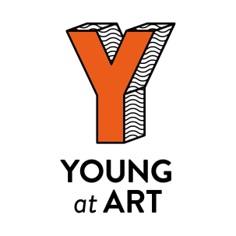

Thank you for allowing your child to go with their school to see a performance as part of the Belfast Children’s Festival 2020. We had a really great time and hope they did too. It will have been a very exciting day. They travelled by bus, visited the ‘Colour of Sound’ exhibition and watched a performance. The show they went to see was called ‘Tetris’ by a company from the Netherlands called Arch8 at the MAC. The exhibition featured some of their own artwork, alongside their classmates and other pupils from throughout Belfast, in response to the Songs and the Soil exhibition on in the MAC by artist Mark Garry
We are sure they will have things to say about it but you may want to ask them some questions as well. We’re suggesting some that might be useful.
• What kind of art was in the exhibition? Did you see anything you made?
• Were there actors or dancers or puppets in the show?
• What kind of room were you in? Was there music? Did the lights change colour?
• Did the performance have a story? What happened? Did the performers use props/objects? How did it make you feel?

As well as any conversations you may have at home, your child’s teacher was given a resource pack with activities to do in school. Please support your child’s school to take advantage of these resources and help make your child’s life more creative.
The Belfast Children’s Festival and the charity running it, Young at Art, have been running all year-round on a not-for-profit basis since 1998.

More information can be found on our website.
www.youngatart.co.uk

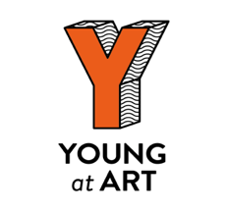

Thank you for allowing your child to go with their school to see a performance as part of the Belfast Children’s Festival 2020. We had a really great time and hope they did too. It will have been a very exciting day. They travelled by bus, visited the ‘Colour of Sound’ exhibition and watched a performance. The show they went to see was called ‘Tetris’ by a company from the Netherlands called Arch8 at the MAC. The exhibition featured some of their own artwork, alongside their classmates and other pupils from throughout Belfast, in response to the Songs and the Soil exhibition on in the MAC by artist Mark Garry
We are sure they will have things to say about it but you may want to ask them some questions as well. We’re suggesting some that might be useful.
• What kind of art was in the exhibition? Did you see anything you made?
• Were there actors or dancers or puppets in the show?
• What kind of room were you in? Was there music? Did the lights change colour?
• Did the performance have a story? What happened? Did the performers use props/objects? How did it make you feel?

As well as any conversations you may have at home, your child’s teacher was given a resource pack with activities to do in school. Please support your child’s school to take advantage of these resources and help make your child’s life more creative.
The Belfast Children’s Festival and the charity running it, Young at Art, have been running all year-round on a not-for-profit basis since 1998.

More information can be found on our website.
www.youngatart.co.uk

